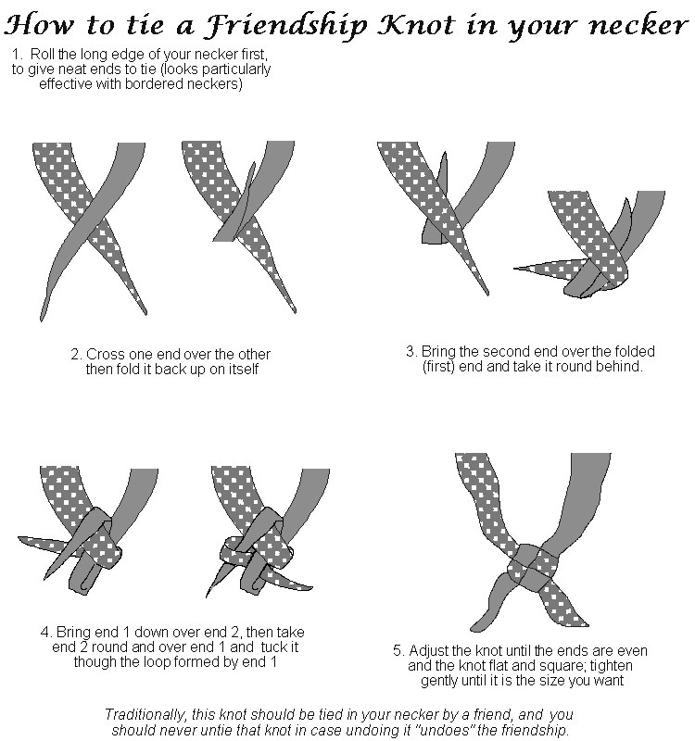
Day 2

Time set off: Time moored:
Miles: Locks: Swing Bridges:
Weather:

