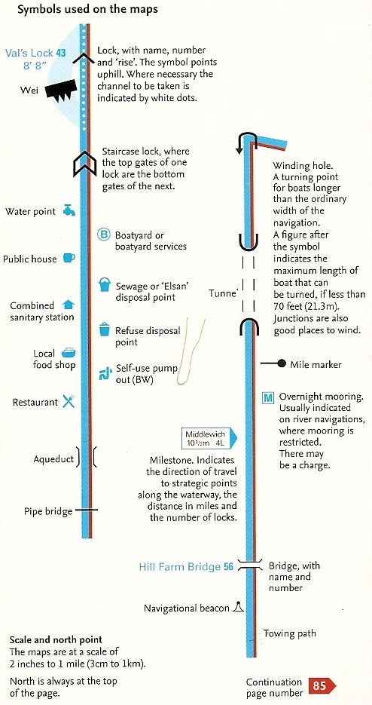
Canal Maps
Canal maps have a lot of symbols on them, but when you know what they all mean you can easily find where you are
All map books differ slightly. These symbols are from the Nicholson series
Now have a go at designing your own boat.
Don’t forget to name it!

