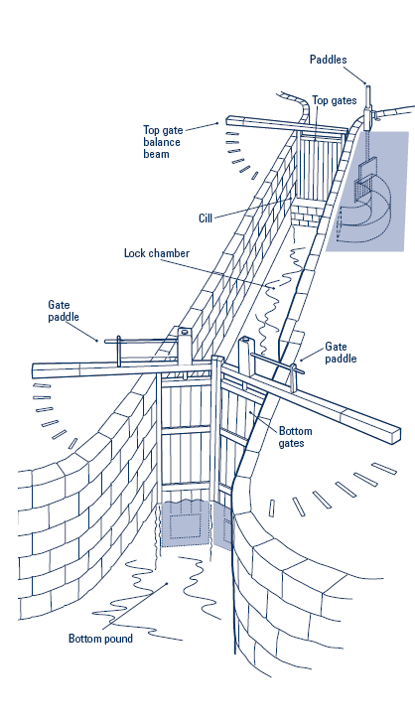
Locks
Locks are like elevators for boats – they enable you to travel up and down hills.

NEVER stand between the balance beam and the canal and ALWAYS know where your windlass is!
Rules
These must be obeyed at all times
No running on the boat or near the canal
Buoyancy aids to be worn at all times above deck
Always follow instructions from leaders
Always step off / on the boat – never jump
Only step on or off the boat when it has stopped moving
Do not let any ropes enter the water
Keep arms and legs within the boat sides when moving

In an Emergency
Alert the leaders who will bring the boat to the bank
Move away from the site of the emergency
Get off the boat calmly, when it is safe to do so
Gather in your teams within sight of the boat
Await further instruction

