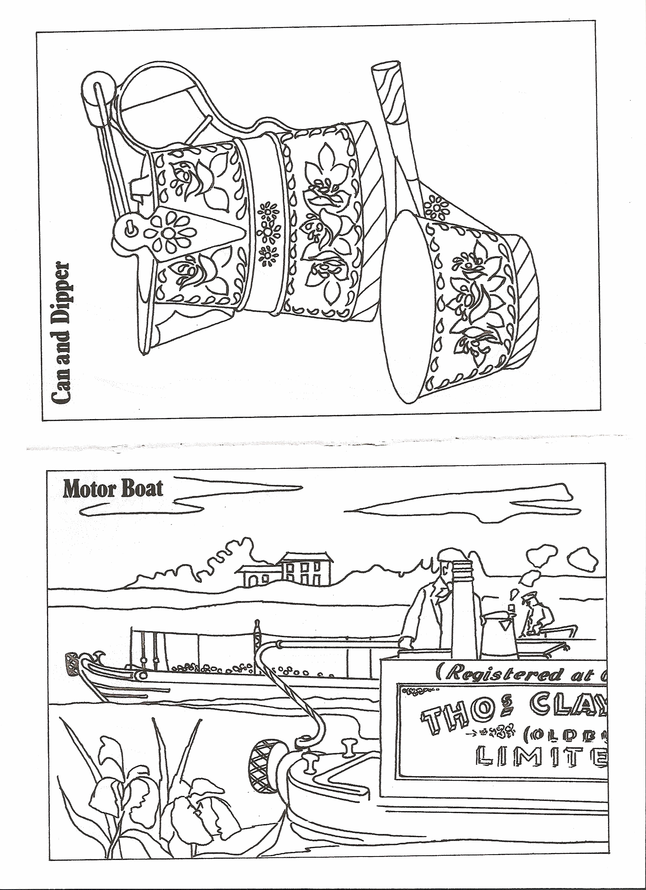

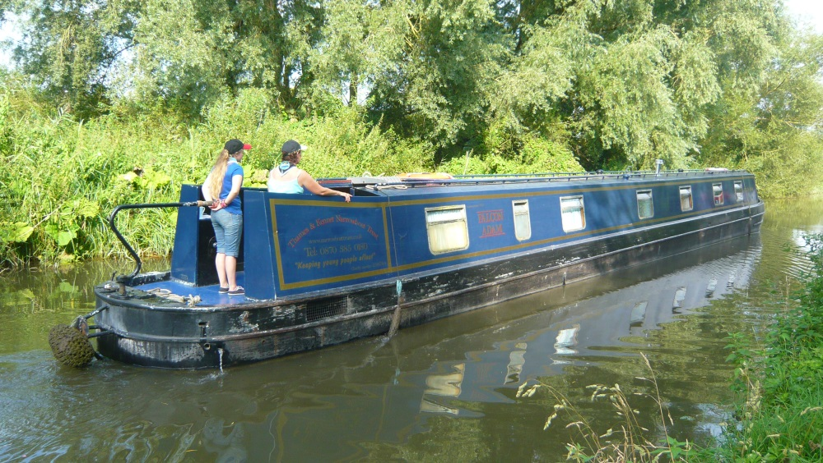

Narrowboating  
on  
Falcon Adam

Name:  
  
Team: